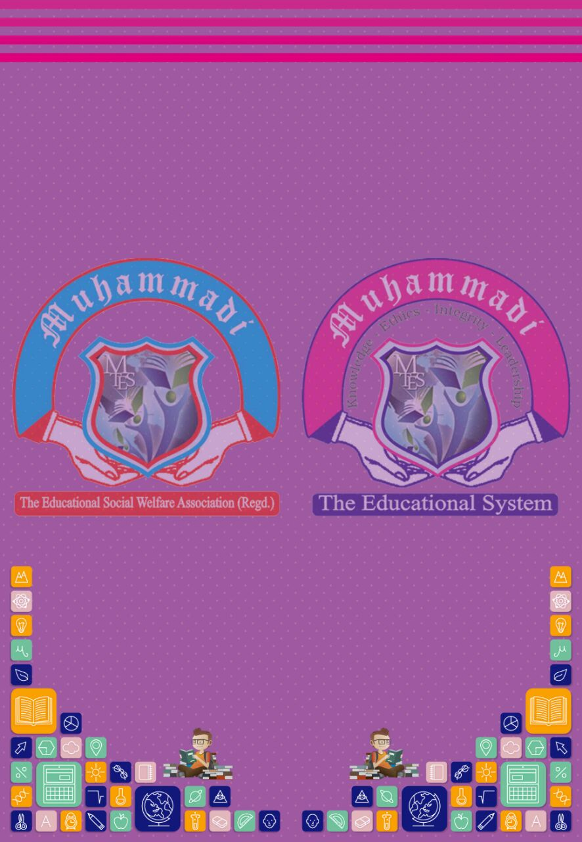

**DOCUMENTATION**

**School Management System**



**Certificate**

This is to certify that Students of HDSE1 (semester 4), have worked on the project titled

**SCHOOL MANAGEMENT SYSTEM**

and have completed the project to our satisfaction.

**ACKNOWLEDGEMENT**

**It gives us immense pleasure in expressing our deep sense of gratitude to our respected teacher, Sir Nehal for his inspiring guidance and thought in the preparation of the project. This project would not have been completed without his valuable guidance and his tremendous effort.**

**PROJECT PERMEABLE**

The project titled **“School Management System”** has been developed as per the requirement of

HDSE-1 for subject Informatics Practices for APTECH.

The source code has been developed in Php Dreamweaver and database is in SQL.

The project deals with creation of forms in Php Dreamweaver,

inserting data in sql tables, deleting, update, searching and report generation.

**PROJECT OVERVIEW**

The following project has been designed with a deep insight into the working of the School Management System. Some of the salient features of the project are:-

**Login System:**

1. **Administrator Login**
2. **Students Login**

**Administrator Login:**

1. Setup New Administrator :

* Change Username
* Change Password

1. Students Fees Area :

* Add Students Fees
* Update Students Fees
* Delete Students Fees
* View Students Fees

1. Students Records :

* Search Students by Id or Name
* Add Students
* Delete Students
* Update Students

1. Student Homework Area :

* View Student Homework
* Add Student Homework
* Update Student Homework
* Delete Student Homework

1. Students Attendence Record
2. Students Chat Area

**Students Login :**

1. Students Fees Area :

* View Students Fees

1. Students Homework :

* View Student Homework

1. Students Attendence Record:

* View Student Attendence

1. Students Chat Area

**Group Members**

* **Mazhar Wajahat**
* **Syed Mudassir Shakir**
* **Syed Abdul Moiz**
* **Haseeb Ahmed**